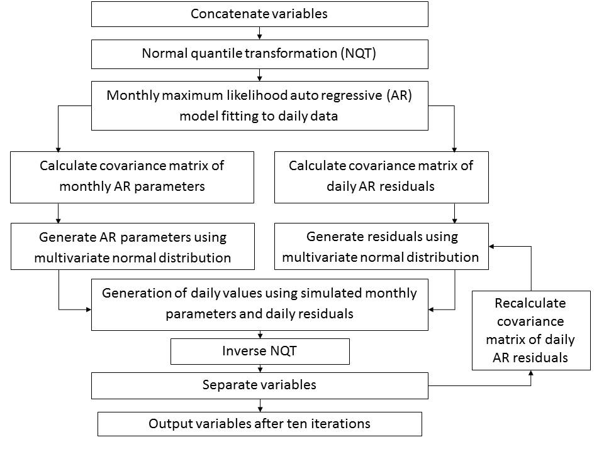

Figure 1: Schematic of simulation procedure.

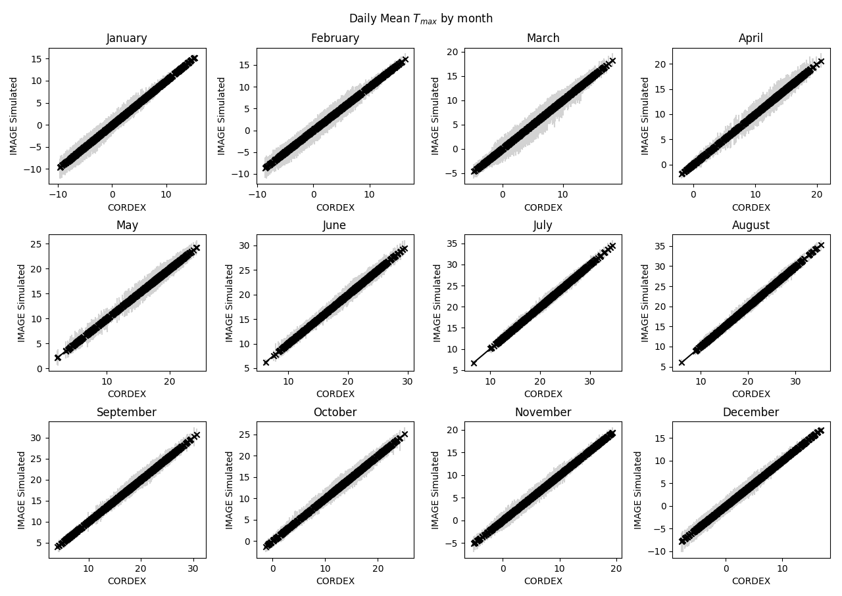

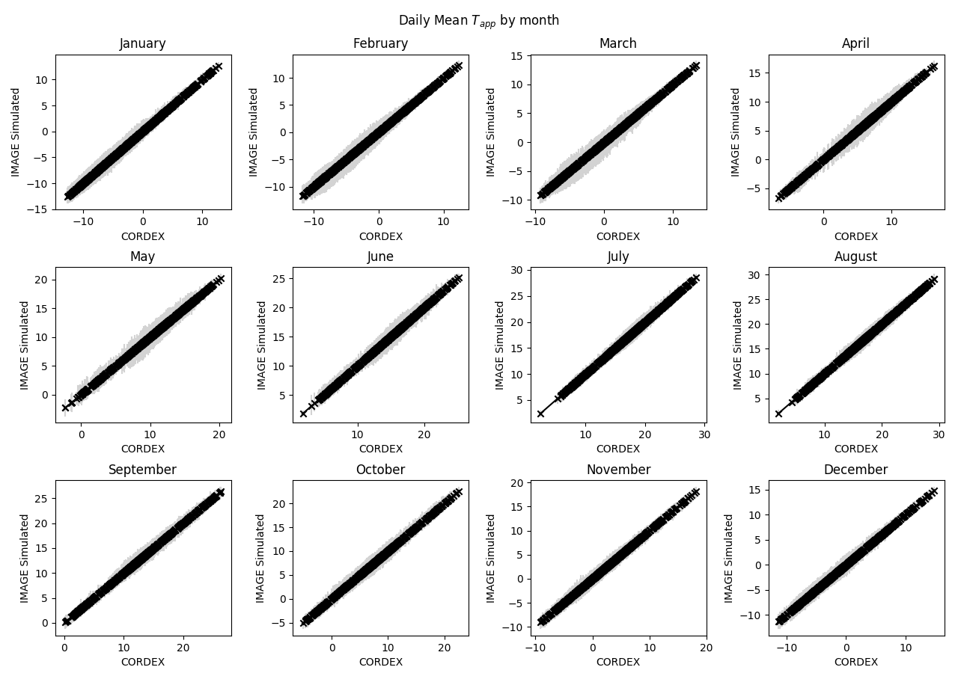

Figure 2: Daily mean of Tmax and Tapp for each month for the IMAGE simulation and the input CORDEX data for 1971-2000. Vertical lines show the range across the ensemble for IMAGE simulation, where each ensemble member has a length of 30 years.

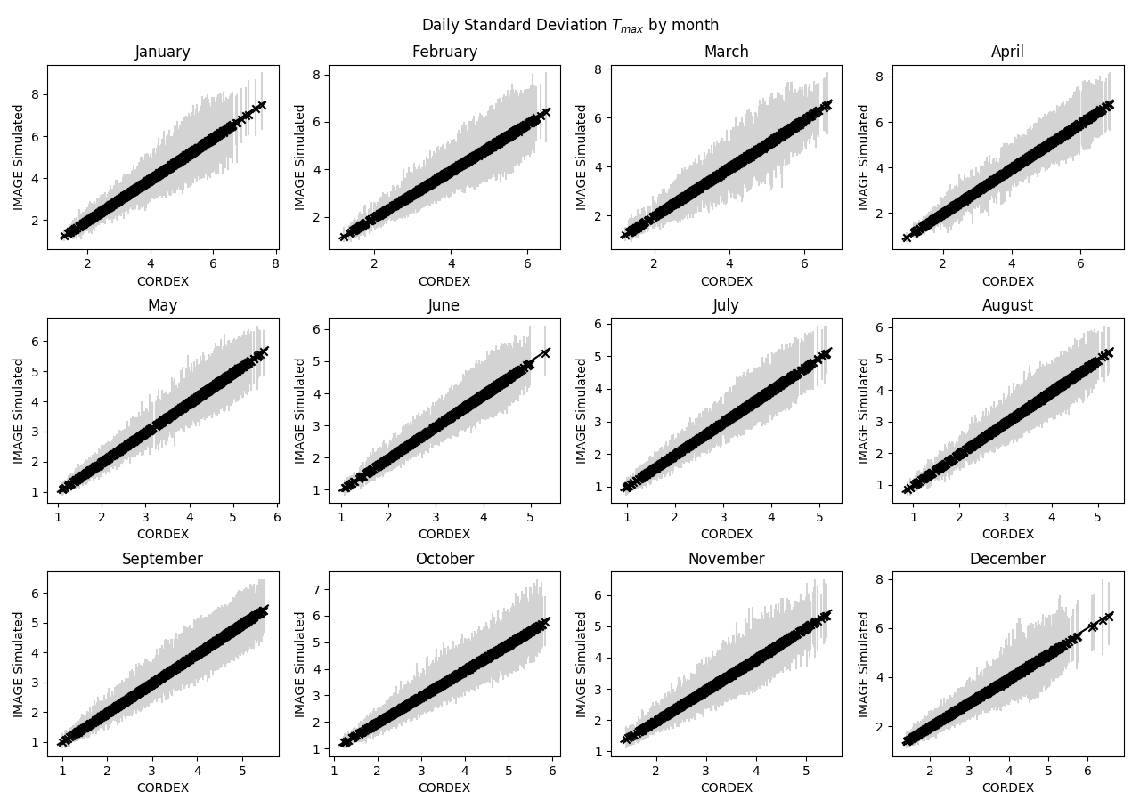

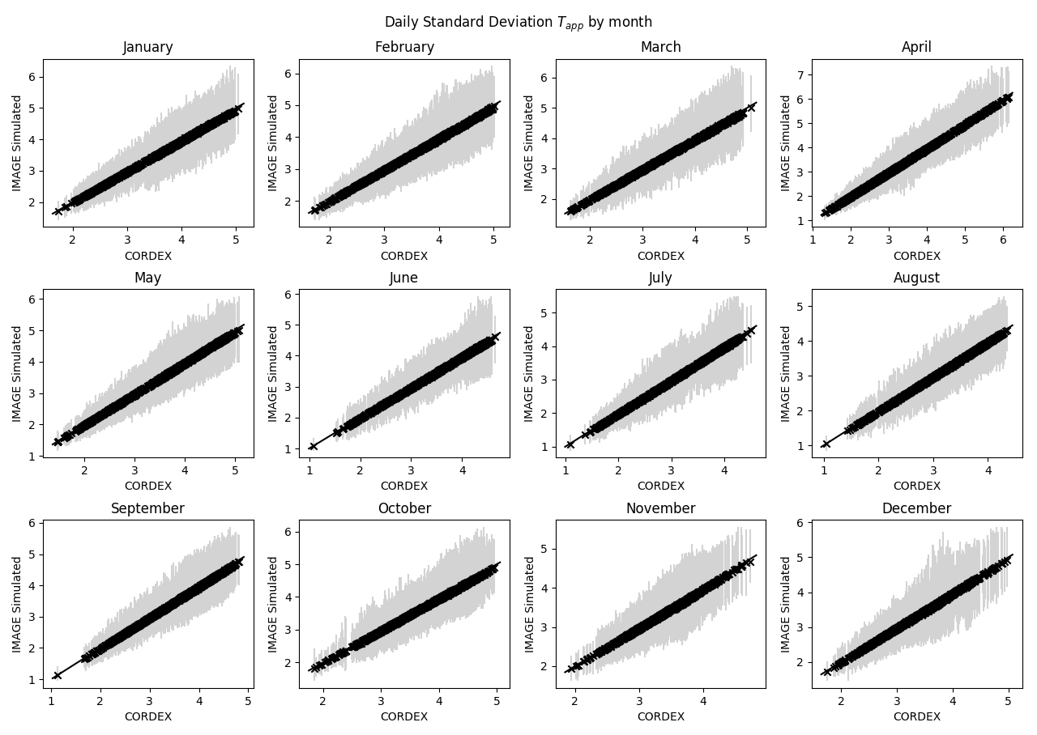

Figure 3: Daily standard deviations of Tmax and Tapp for each month for the IMAGE simulation and the input CORDEX data for 1971-2000. Vertical lines show the range across the ensemble for IMAGE simulation, where each ensemble member has a length of 30 years.

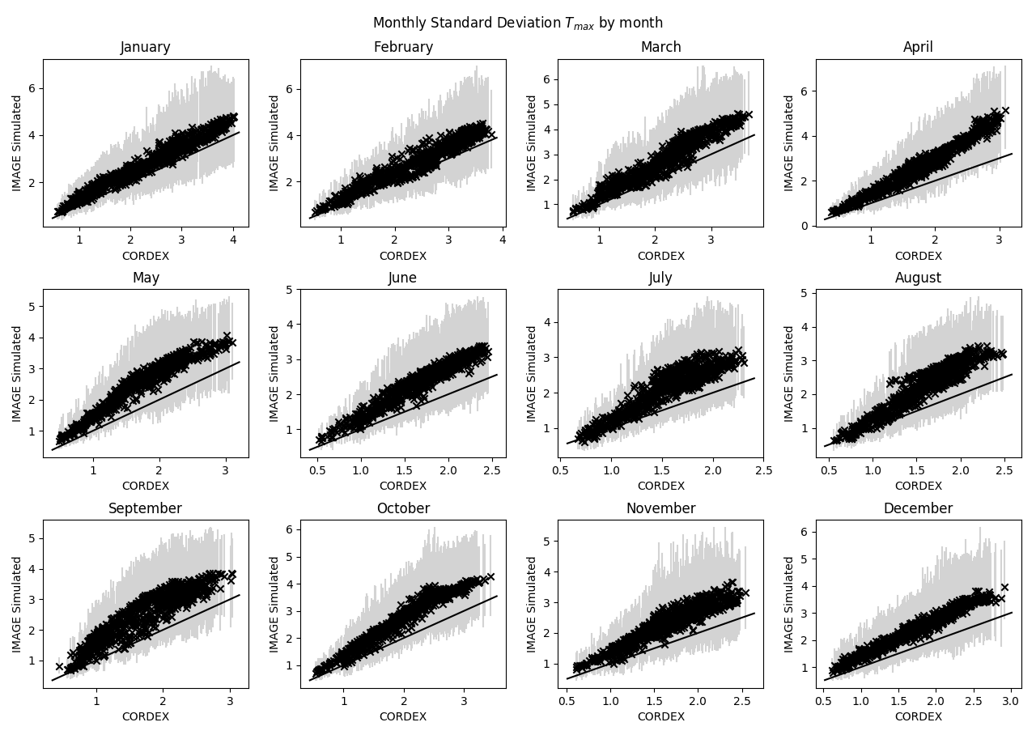

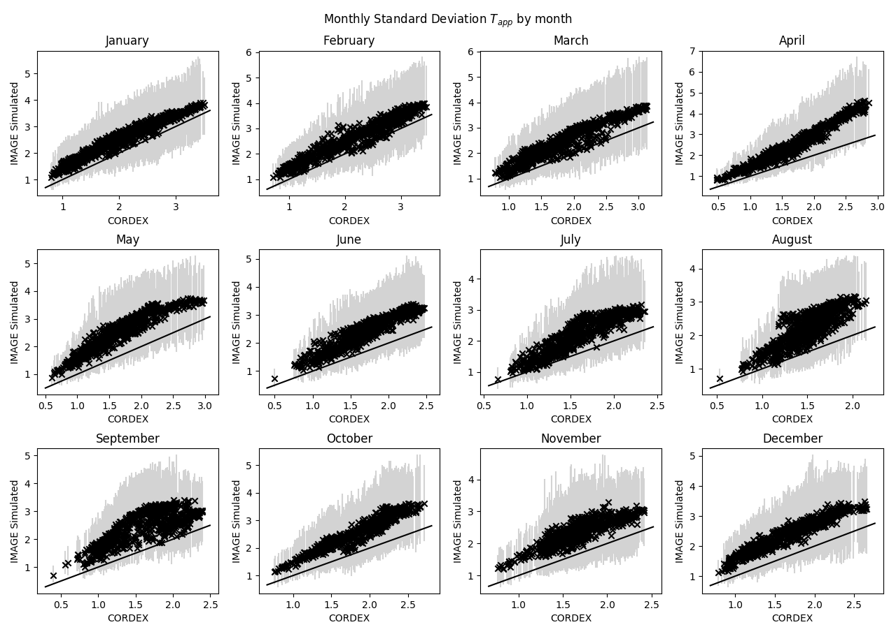

Figure 4: Monthly standard deviations of Tmax and Tapp for each month for the IMAGE simulation and the input CORDEX data for 1971-2000. Vertical lines show the range across the ensemble for IMAGE simulation, where each ensemble member has a length of 30 years.

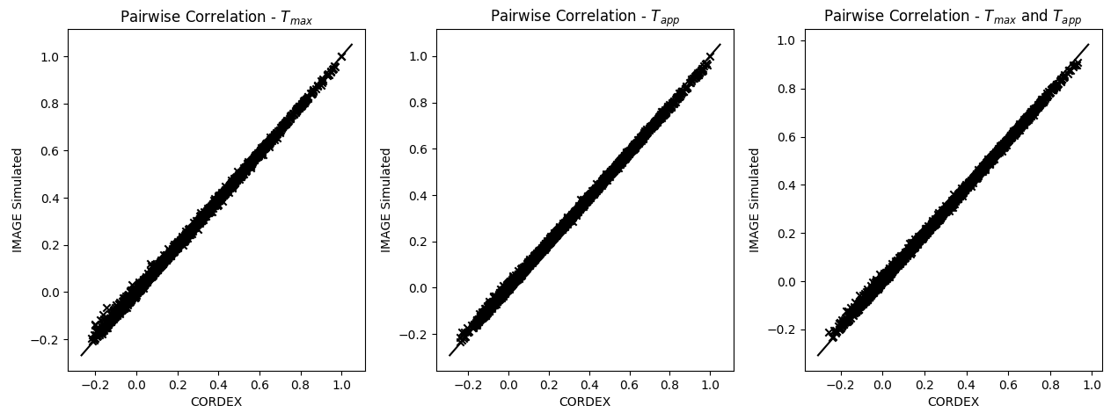

Figure 5: Pairwise Pearson’s correlation coefficient for Tmax­, Tapp, and cross-correlation between Tmax and Tapp for the IMAGE simulation and the input CORDEX data for 1971-2000.

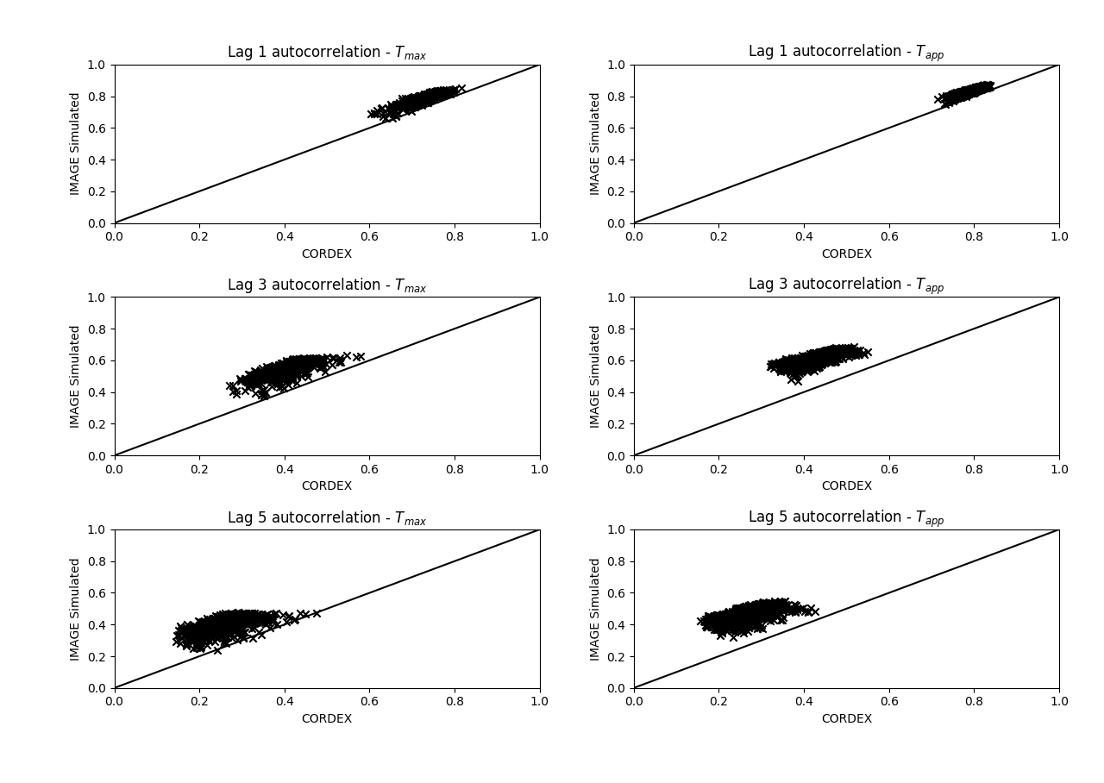

Figure 6: Autocorrelation of Tmax and Tapp for lags of 1,3 and 5 days respectively for the IMAGE simulation and the input CORDEX data for 1971-2000.

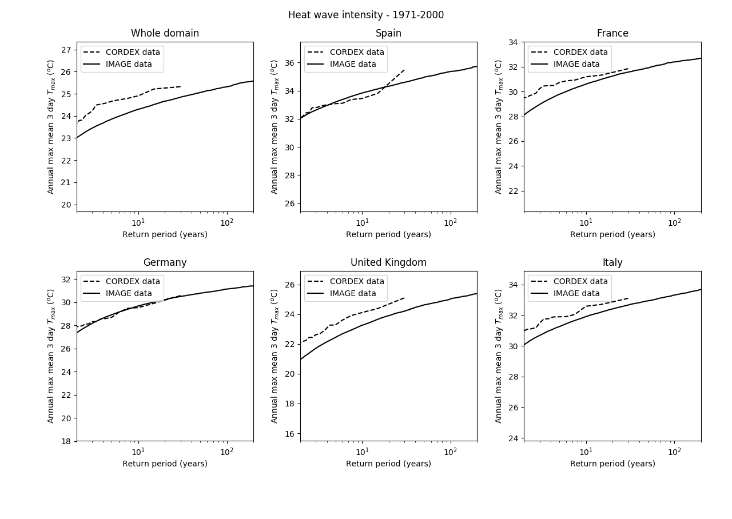

Figure 7: Return value of heat waves, as measured by intensity, for the whole domain and five countries within the domain for the IMAGE simulation and input CORDEX data for 1971-2000.

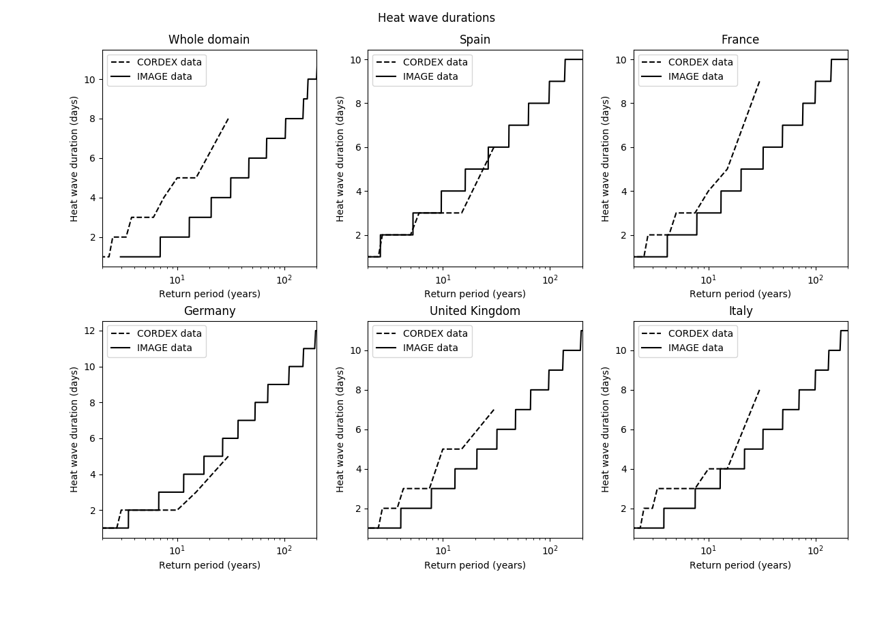

Figure 8: Return value of heat waves, as measured by duration, for the whole domain and five countries within the domain for the IMAGE simulation and input CORDEX data for 1971-2000.

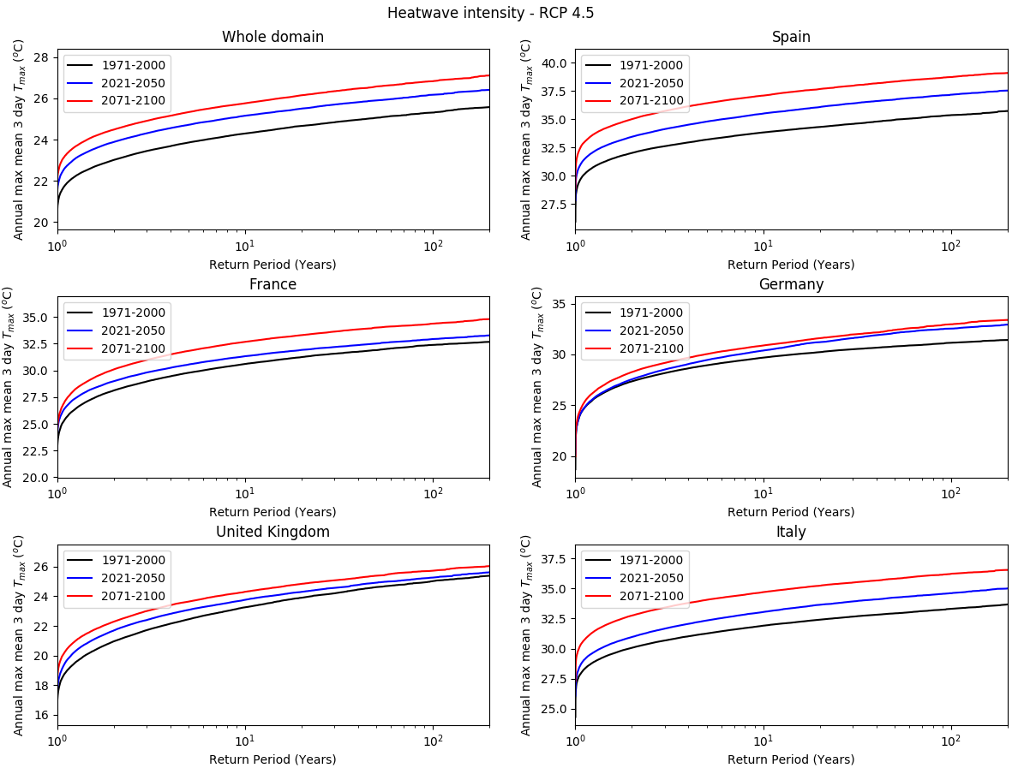

Figure 9: Return values of heat waves, as measured by intensity, for the whole domain and five countries within the domain for the IMAGE simulation under the RCP 4.5 scenario.

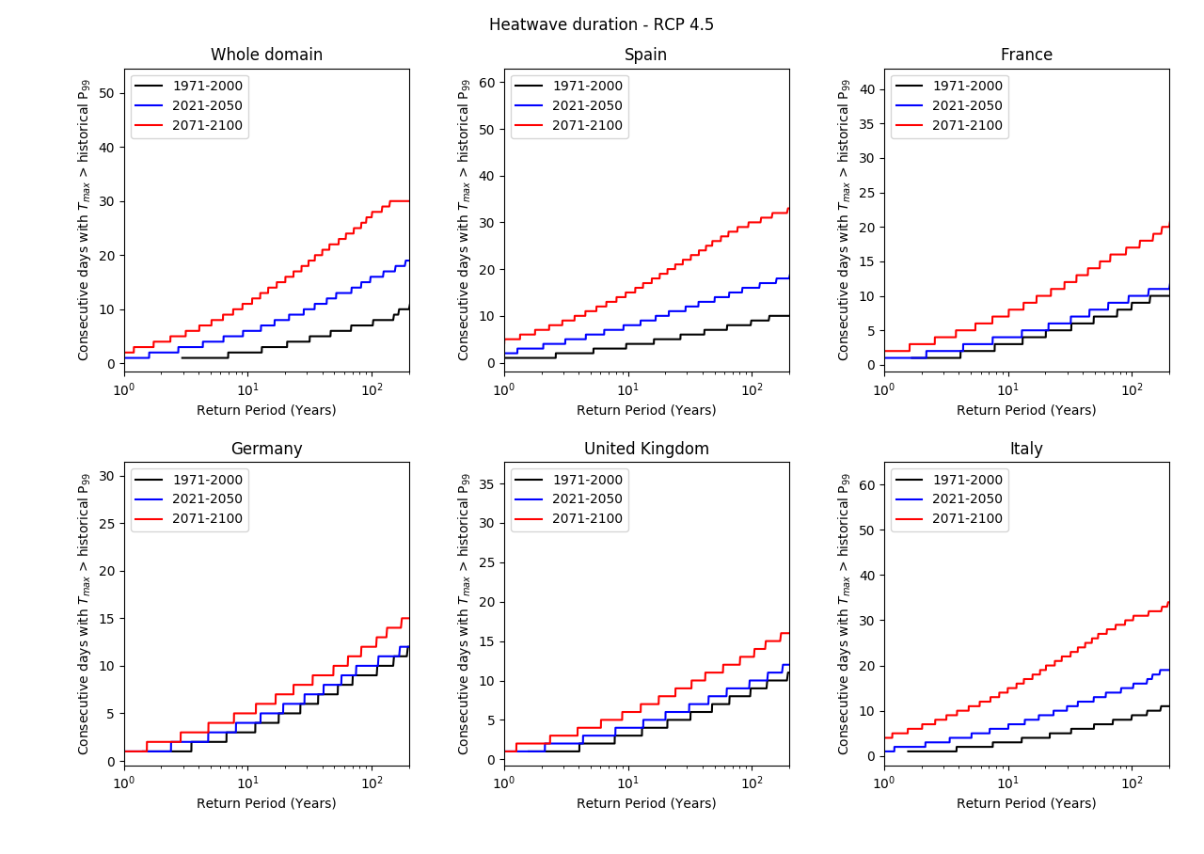

Figure 10: Return values of heat waves, as measured by duration, for the whole domain and five countries within the domain for the IMAGE simulation under the RCP 4.5 scenario.

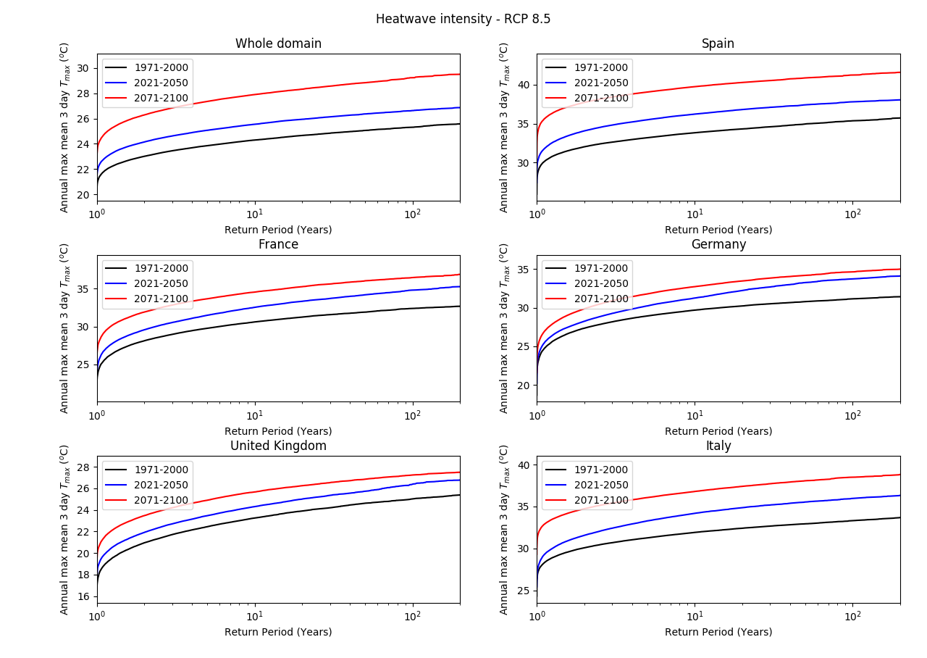

Figure 11: Return values of heat waves, as measured by intensity, for the whole domain and five countries within the domain for the IMAGE simulation under the RCP 8.5 scenario.

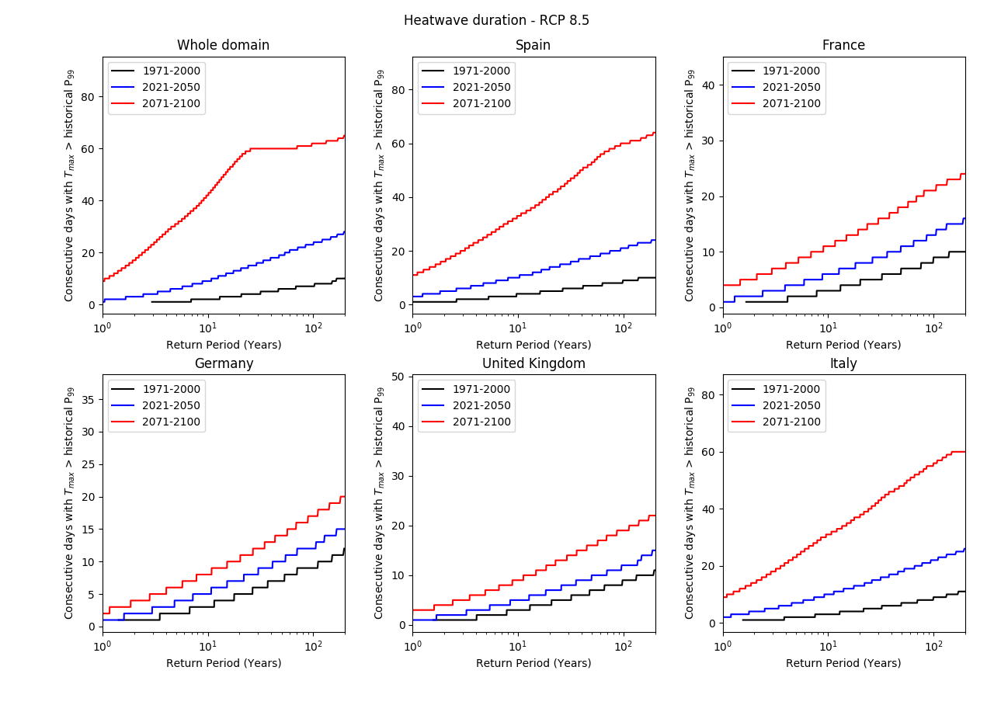

Figure 12: Return values of heat waves, as measured by duration, for the whole domain and five countries within the domain for the IMAGE simulation under the RCP 4.5 scenario.

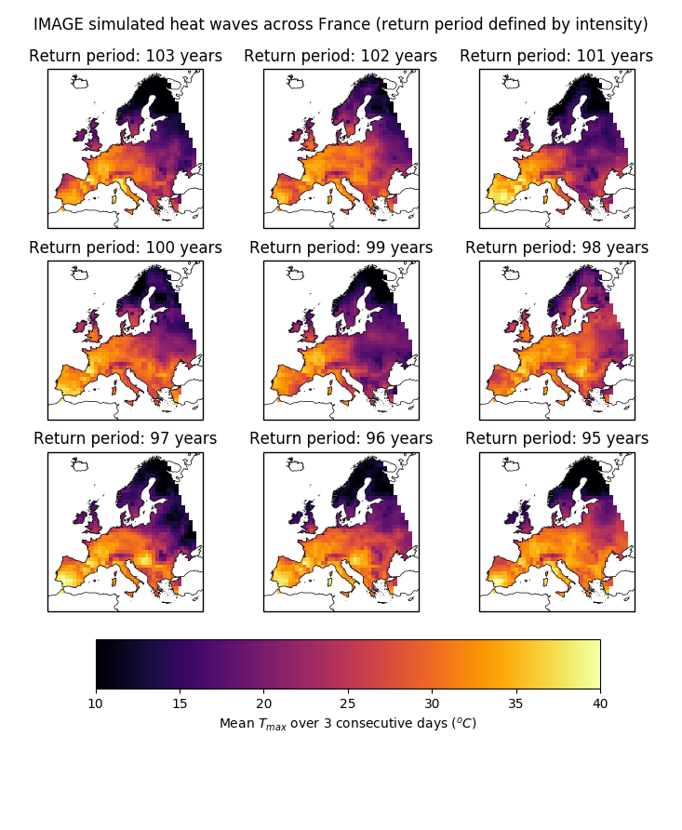

Figure 13: Maps of mean Tmax over 3 consecutive days across Europe for heat waves in France, as measured by intensity, with return periods between 95 and 103 years.

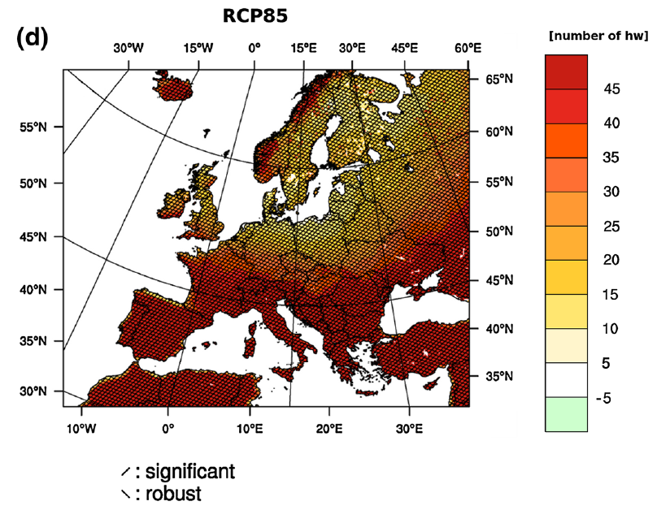

Figure 14: Reproduced from Jacob et al (2014); map of the ensemble mean number of additional heat waves for the period 2071-2100 compared to the period 1971-2000 for the CORDEX experiment under the RCP 8.5 scenario.

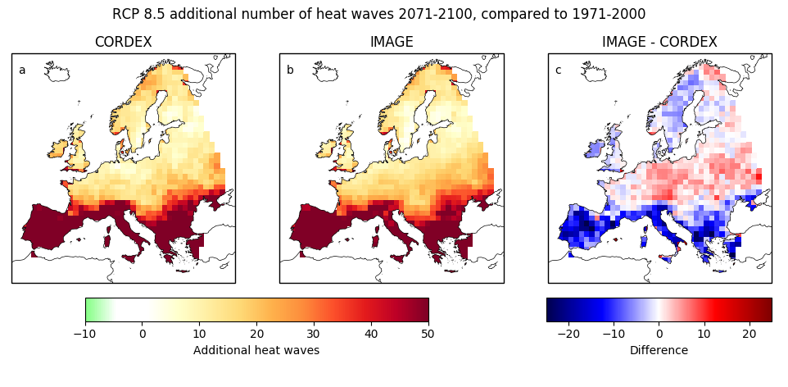

Figure 15: Additional number of heat waves in the period 2071-2100 compared to the period 1971-2000 under the RCP 8.5 scenario, for (a) the input CORDEX data and (b) the IMAGE simulation, as well as (c) the difference between the number predicted by the IMAGE simulation and the input CORDEX data.